XPAGMUS 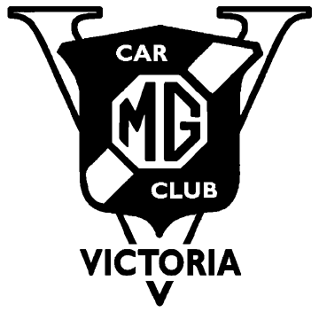
SUNDAY NOVEMBER 24TH, 2019.
START: Meet at Club Rooms for 9.30 am Departure
TO: Dr Tait’s Live Steam Railway, Hoddles Creek
415 Lusatia Park Road.
BYO
- BBQ meat/picnic lunch & drinks
- Picnic chairs/table & sun umbrella, sunscreen & hat.
- Your T Type MG
- Gift for your children/grand children to the value of $15 suitably labelled with the child’s name in bold type as Santa’s eyesight is not that good after the long trip from the north pole in a TF.

ROUTE DIRECTIONS –

Go south on Norcal Rd, TL Mt Pleasant Rd,
TL Canterbury Rd go east. TR Boronia Rd, vere left onto Mountain Highway, pass through Bayswater, stay on Mountain Highway. Cross Scoresby Rd, Dorset Rd & continue S.O. to The Basin on Mountain Highway.
At Sassafras TL onto Mt Dandenong Tourist Rd, at Olinda TR onto Olinda-Monbulk Rd, pass through Monbulk, at end of Main St TR onto Emerald-Monbulk Rd, at Emerald RAB in at 6 out at 9 onto Belgrave-Gembrook Rd. TL Maccesfield Rd, TR Parslows Rd, TL Healesville-Koo Wee Rup Rd.
At Woori Yallock TAKE CARE TR onto Warburton Hwy, then TR onto Lusatia Park Rd, TL into Dr Tait’s property at No 415. There is an orange shipping container near the gate.

